::Library:Application Support:Microsoft:Office:Clipart:Personal:bs01872_.wmf

**The University of British Columbia is accepting applications for a new cohort beginning Summer 2015.**

Application Deadline: December 1, 2014

* 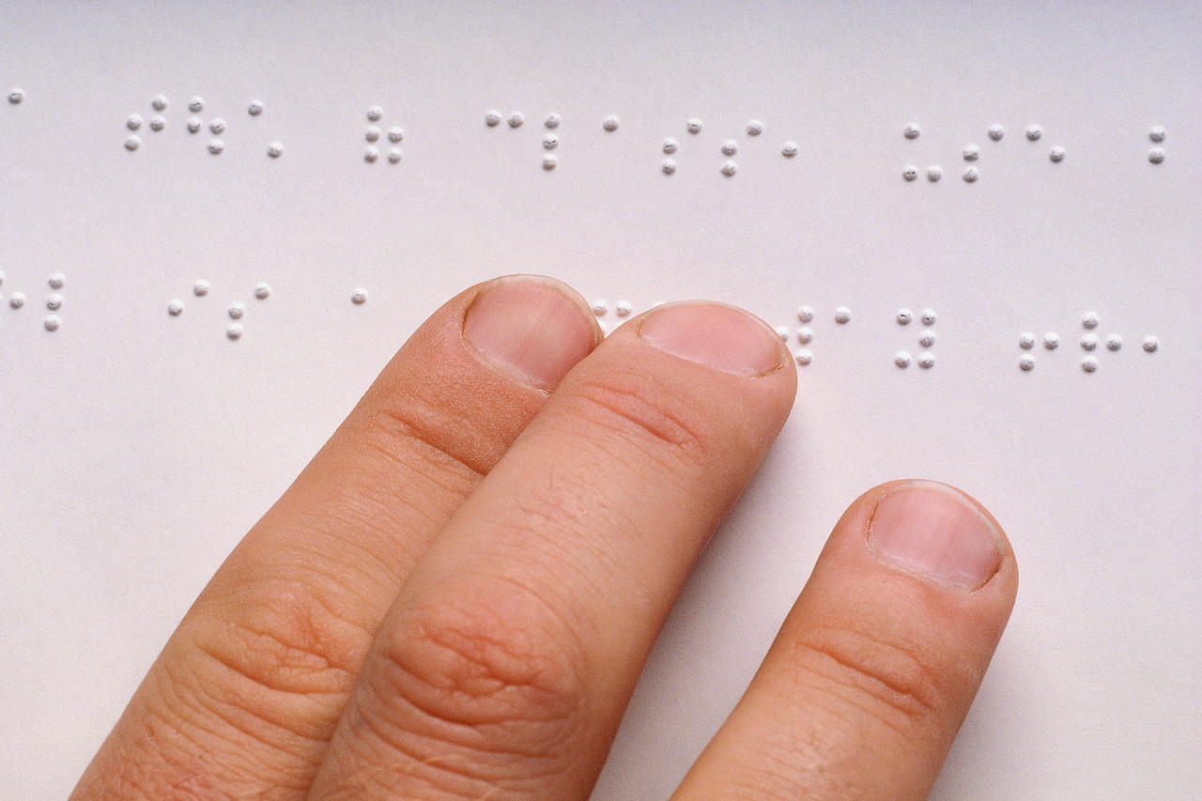Join a highly specialized group of professionals dedicated to providing quality education to students who are blind or visually impaired.
* Continue teaching while you get your Masters degree with both an M.A. and M.Ed. available (applicants must currently have a teaching degree).
* Learn about adapting the core curriculum and instructing in the expanded core curriculum for students who are blind or visually impaired.
* Take On-line courses during the school year and face-to-face courses over three summers on UBC’s Vancouver campus.
* Complete your program by August 2017
* You may be eligible for financial assistance through the BC Loan Forgiveness Program
* Some merit-based scholarship opportunities are available once in the program

**For more information about the program contact:**

Dr. Cay Holbrook ([cay.holbrook@ubc.ca](mailto:cay.holbrook@ubc.ca)) and Dr. Kim Zebehazy ([kim.zebehazy@ubc.ca](mailto:kim.zebehazy@ubc.ca))

**For Application information Contact:**

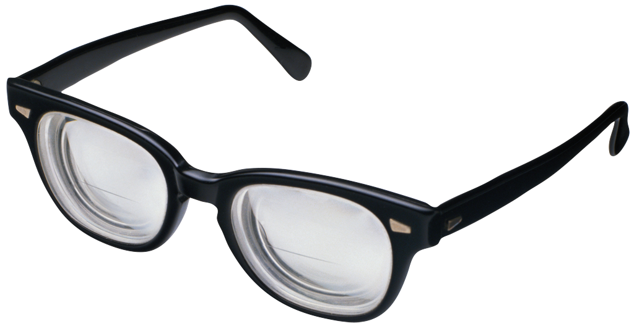Alex Allen: [alex.allen@ubc.ca](mailto:alex.allen@ubc.ca) or 604-822-5351